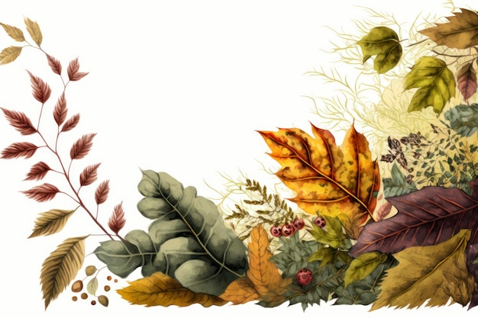
September Events
September 5 – Community Dinner
September 6 – Communion Sunday
September 13 – Fellowship Meal

Sundays – Adult Bible Study, 9:30am
Children’s Sunday School, 10:30am
Sundays -Youth Group, 5:30-7:30pm
Wednesday evening Bible Study –
summer break
Fridays – Women’s Bible Study, 10am
-Men’s Bible Study, 10am
@ the VanDeusen’s

