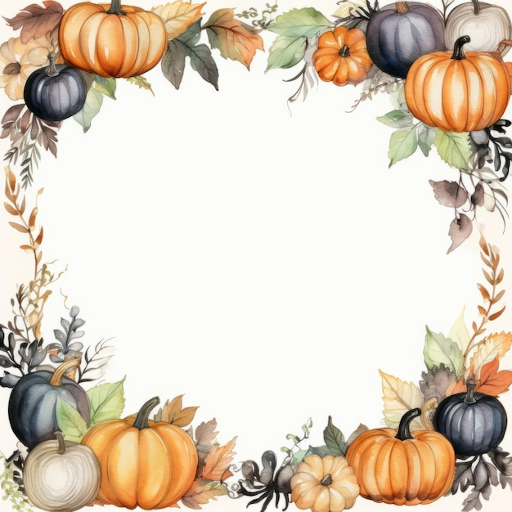

October Events
October 3 – Community Dinner
October 4– Communion Sunday
October 9 & 10 – Rummage Sale
October 11 – Fellowship Meal
October 24 – Harvest Festival

Sundays – Adult Bible Study, 9:30am
Children’s Sunday School, 10:30am
Sundays -Youth Group, 5:30-7:30pm
Fridays – Women’s Bible Study, 10am
-Men’s Bible Study, 10am @ the VanDeusen’s

