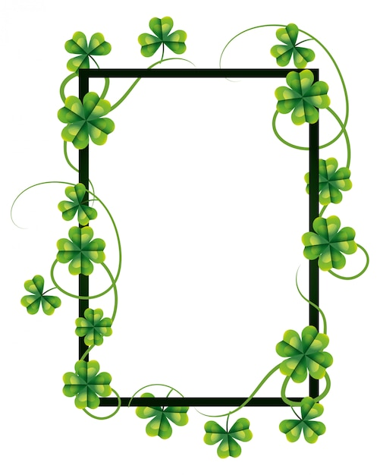
March Events

March 1 – Communion Sunday
March 7 – Community Dinner
March 8 - Fellowship Meal
March 29 – Palm Sunday
____________________________________________
Sundays – Adult Bible Study, 9:30am
Children’s Sunday School, 10:30am
Sundays -Youth Group, 5:30-7:30pm
Wednesday evening Bible Study – 6pm
Fridays – Women’s Bible Study, 10am
-Men’s Bible Study, 10am
@ the VanDeusen’s

