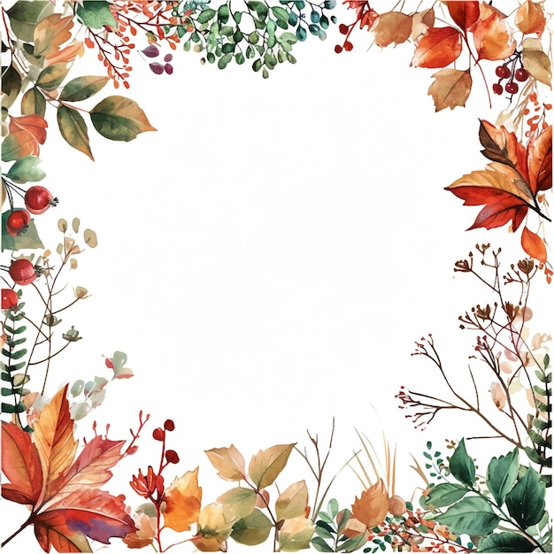

November Events
November 1 – Red Cross Blood Drive
November 1 – Community Dinner
November 2 – Communion Sunday
November 9 – Fellowship Meal
____________________________________________
Sundays – Adult Bible Study, 9:30am
Children’s Sunday School, 10:30am
Sundays -Youth Group, 5:30-7:30pm
Wednesday evening Bible Study – 6pm
Fridays – Women’s Bible Study, 10am
-Men’s Bible Study, 10am
@ the VanDeusen’s

