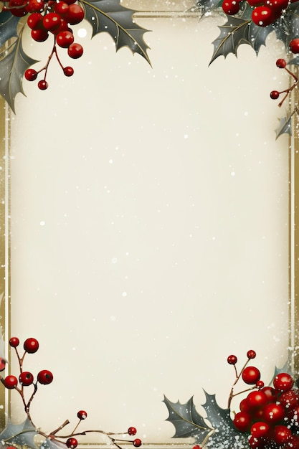
December Events

December 6 – Community Dinner
December 6 – Gardiner Christmas Parade
December 7 – Communion Sunday
December 14 – Fellowship Meal
December 24 – Christmas Eve
Candlelight Service, 6pm
December 25 – Christ was born!
____________________________________________
Sundays – Adult Bible Study, 9:30am
Children’s Sunday School, 10:30am
Sundays -Youth Group, 5:30-7:30pm
Wednesday evening Bible Study – 6pm
Fridays – Women’s Bible Study, 10am
-Men’s Bible Study, 10am
@ the VanDeusen’s

